This is your quasi-daily update on the 2022 ABoVE Airborne Campaign

Thursday 14 July, 2022 (DOY 194) – Bastille Day Edition

Chip Miller is in Fairbanks, AK.
Peter Griffith is in Maryland.

NASA’s 2022 airborne activities are scheduled to include AVIRIS-NG hyperspectral imaging (5 July – 25 August) and the L-band polInSAR (9 August – 22 August). Flights will provide acquisitions across the ABoVE domain in Alaska and northwestern Canada in coordination with ABoVE field work

ABoVE will coordinate with the DLR CoMet 2.0 Arctic (operating from Edmonton ~12 Aug – 15 Sep), G-LiHT (6-30 July in southern/SW Alaska), and NEON AOP (operating out of Deadhorse AK 20 July – 22 Aug) teams.

More information may be found on the summary page for the ABoVE 2022 Airborne Campaign

Sensor/Aircraft Summaries and 72-hour Look Aheads

AVIRIS-NG (Dynamic Aviation B-200 N53W)
July 2: Transit Great Falls MT (GTF) – Bellingham, WA – Juneau, AK – Fairbanks, AK

July 3: Crew rest day; Clean AVIRIS window

July 4: Hard Down Day; >5000 lightning strikes forecasted for AK
Jackie Hung and a Woodwell research team are in the YK Delta

July 5: First flight day.
Excellent cloud-free conditions found in several locations, but ALL LINES had significant low level smoke interference. It was impossible to see the ground in several locations. These are likely the conditions in Alaska until the August rains begin to extinguish the large wildfires.
Cloud front was further east than forecasted, so Beaver AK area box was aborted after 1 line. Moved north along the Dalton Hwy into less cloudy areas. Acquired several lines in the Toolik Lake area before clouds moved in there. Returned to the Fairbanks area where boxes over the Goldstream Valley, Nugget fire scar, and the BNZ LTER/APEX targets were acquired

July 6: Flight day #2.
Flew Beaver, AK grid, Coldfoot and Bettles lines, Grouse Creek fire scar grid, Hess Creek fire scar line, and CPCRW/flux towers line. Less smoky conditions in the north, but still far from ideal. Visible wavelengths severely compromised.

July 7: Down Day
Resetting crew clocks in advance of extended good weather forecasts

July 8: Down Day
Replacement pilot arrival delayed due to cancelled flight

July 9: Flight day #3.
Forecast for clear skies and low smoke over eastern North Slope
Flew lines over Dalton Hwy, Anaktuvuk River fire scar, Nuiqsut, and Deadhorse areas. Attempted flights over North Slope coastal boxes, but sea ice still covered more than 50% of the lines – will need to revisit these lines towards the end of July

July 10: Flight day #4.
Forecast for clear skies and no smoke over the Kotzebue/Noatak region
Tranist – entire Interior filled with smoke south of the Brooks Range
Sortie #1: flew Noorvik and Kotzebue grids
Sortie #2: flew all Lower and Upper Noatak Valley lines and part of the Selawik grid
Outstanding conditions all day long: clear skies and no smoke
Observed scattered clouds over the Seward Peninsula with increasing high cirrus during the day. Returned to dense smoke advisory in Fairbanks

July 11: Down Day
Clouds moving in across Alaska, no combination of clear skies and smoke-free conditions in any priority areas, so called for a down day after 2 long flying days

July 12: Down Day (Weather).
Forecasts at 0800 showed areas clear skies over Seward Peninsula and Kotzebue, but with significant uncertainty. Forecasts for Wed 7/13 showed better conditions, so we cancelled for today and are targeting Seward Peninsula (NGEE-Arctic) sites and completion of Kotzebue area lines on Wed 7/13. Mid-day satellite imagery shows that this was a good call with cloud cover remaining across the state, even the Sew Pen/Noatak region – see satellite imagery below

July 13: Flight day #5.
Forecasted large area of clear sky conditions over NW Alaska covering Noatak and Seward Peninsula. Smoke forecast shows it all moving into SE Alaska below a Wiseman-Bettles-Galena-Kaltag line. Acquired excellent data over the Huslia grid, then moved to the Seward Peninsula where clouds interfered with the acquisitions over the Council grid, but excellent data were obtained over Kougarok and Teller sites with NGEE-Arctic teams on the ground at those sites. 2nd attempt at acquiring the Council grid after refueling was more successful, although clouds still interfered with one end of the watershed

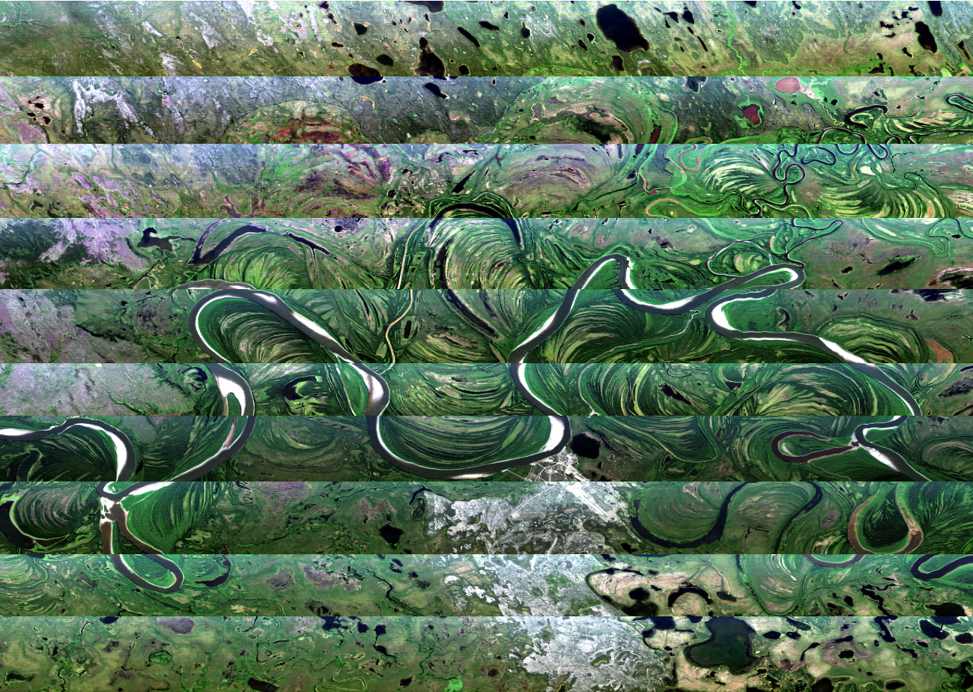

Composite image of the Huslia grid made from data acquired on 7/13/22. Huslia village is in the middle of the image along the bend in the Koyukuk river

July 14: Down Day (weather).
No storming of the Bastille for the ABoVE AVIRIS team today. Combination of dense low-level clouds and/or high cirrus across the state left no viable flight options.

Revised Alaska priorities:
Successful acquisition of all terrestrial lines around Deadhorse and along the Dalton Hwy down to Toolik Lake as well as the NGEE-Arctic sites on the Seward Peninsula allows us to reprioritize remaining Alaska acquisitions:
- Priority 1 = YK Delta grid
- Priority 2 = Interior AK/Fairbanks Area under smoke-free conditions
- Priority 3 = Barrow/Atqasuk Area and Deadhorse coastal regions
- Priority 4 = King Salmon and Anchorage areas
- Priority 5 = Dempster Hwy mountain sites (from Fairbanks)
- Priority 6 = Whitehorse/Kluane Lake/Skagway areas (refuel in Juneau)

Delaying Barrow and Deadhorse coastal flights as long as possible to capture later phenology (Barrow) and minimal coastal sea ice

Peter Kirchner alerted us to the fact that the Contact Creek fire near King Salmon burned right over one of his SWAN autonomous measurement sites and that he has data before, during, and after the fire. Adding a box to cover the fire perimeter for this unique opportunity. The fire scar also falls under one of our established SAR lines, so we will have that data as well

Phil Brodrick continues to post AVIRIS quicklooks for all 2022 ABoVE flights: https://avng.jpl.nasa.gov/pub/ABoVE/quicklooks/.

Kyle Kovach and Univ Wisconsin field team are collecting foliar samples along the Dalton Hwy near Deadhorse through the end of the week. These will serve as ground truth for the AVIRIS data acquired on 7/9/22

AVIRIS Operations 72-hour Look Ahead

July 15: Potential flight day.
Dense cloud cover forecasted across Alaska all day. No obvious targets. Watch for updates

July 16: Potential flight day.
Forecasts show continuing cloud cover across Alaska. Possible break over the YK Delta. Watch for updates

July 17: Potential flight day.
Forecasts show continuing cloud cover across Alaska. No obvious targets. Watch for updates

G-LiHT (Dynamic Aviation Beechcraft King Air N80Y)
Integration & Testing (Bridgewater, VA): 28-30 June 2022
Transit to AK: 1-6 July 2022
Base of Operation and Dates :
Kodiak, AK -- 6-16 July 2022
Aniak, AK -- 16-26 July 2022
Kodiak, AK -- 26-30 July 2022
Description of science flights and motivation

July 2: G-LiHT transits from Bridgewater VA – Perry, IA
July 3: G-LiHT transits from Perry IA – Sheridan County, WY
July 4: G-LiHT transits Sheridan County, WY – Wenatchee, WA
July 4: G-LiHT transits Sheridan County, WY – Wenatchee, WA – Juneau, AK
July 5: G-LiHT transits Juneau, AK – Kodiak AK; in position to begin operations
July 6: G-LiHT in Kodiak AK; no flights on tracker
July 9: G-LiHT in Kodiak AK; 2 sorties near King Salmon, AK
July 10: G-LiHT in Kodiak AK; 2 sorties near King Salmon, AK
July 11: G-LiHT in Kodiak AK; flying near Dillingham, AK
July 12: G-LiHT in Kodiak AK; no activity
July 13: G-LiHT in Kodiak AK; Kodiak Island flight
July 14: G-LiHT in Kodiak AK; no activity as of 1330 AKDT

NEON Airborne Observation Platform #1 (Daily Flight Reports)
July 17 – Transit through Fairbanks
July 18 – Aug 22: First candidate flight day – Toolik Lake area

L-band SAR (JSC G-III NASA2)
June - July: planned non-ABoVE CONUS flights
Aug 9: Transit Houston – Saskatoon (TBC)
Aug 10: BERMS area TomoSAR
Aug 11: Transit to Yellowknife

CoMet 2.0 Arctic (HALO G-550 D-ADLR)
Aug 6: Transit to Edmonton
Aug 10: First candidate flight day

Weather Forecast: ABoVE Domain

GEOS-FP for ABoVE: https://fluid.nccs.nasa.gov/missions/mission_ABOVE/
HRRR for Alaska: https://rapidrefresh.noaa.gov/alaska/
Windy weather visualization: https://www.windy.com/
FAA Weather Cameras – Interactive map with Alaska and Canadian cameras: https://weathercams.faa.gov/
Alaska Fires and Smoke Predictions: http://smoke.alaska.edu/current_fires.html
Sea ice extent: https://www.weather.gov/afc/ice
Solar Elevation Calculator: https://aa.usno.navy.mil/data/AltAz

Fire activity updates 7/14/22 http://smoke.alaska.edu/current_fires.html :

1300 AKDT on 7/14/22: Fairbanks AQI = 5 !!!
Clear air in Fairbanks for the first time since we started
https://www.iqair.com/us/usa/alaska/fairbanks

Lightning strike map
https://www.arcgis.com/apps/webappviewer/index.html?id=f5c311fa930d4831916c3f27984e97fd&extent=-21498469.1666%2C7047820.6016%2C-12281998.0441%2C11636488.2836%2C102100

Last updated: 14 Jul 2022, 13:00. Data from the Alaska Interagency Coordination Center, which is currently tracking 500 fires in Alaska (active, smoldering or in the process of being demobilized).

Multiple large fires burning west of Fairbanks:
- Minto Lakes (37,523 acres, no change since 7/11/22)
- Tanana River (23,725 acres, +100 acres since 7/12/22)
- Clear (70,896 acres, +300 acres since 7/12/22)
- Chitanana (93,528 acres, +45000 acres since 7/12/22)

Multiple large (>100,000 acre) fires burning in SW Alaska and the YK Delta contributing to smoky conditions across Interior AK. Fires of particular note:
- Douglas (20,945 acres) south of Coldfoot is burning on both sides of the Dalton Hwy and may impact travel between Fairbanks and Deadhorse
- Hog Butte (199, 436 acres) between Lake Minchumina and Nikolai
- Tatlawiksuk (226,000 acres), Aghaluk Mountain (116,000 acres), and Koktuli River/Pike Creek (205,866 acres) causing smoke over most of western and Interior AK
- East Fork (167, 000 acres) and Apoon Pass (84,000 acres), both near St Mary’s

Minto Lakes fire
Discovered: 6/21/2022 4:34:39 PM
Last updated: 7/14/2022 11:50:14 AM
37523 acres
Minimal activity over the fire area with heat present in exceptionally dry and deep duff and heavier fuels. Precipitation over the fire last night/early morning provided a wetting rain with most of the rain falling over the east side of the fire. Rainfall amounts over the last 24 hours (12 pm to 12pm AKDT) ranged from 0.02 - 0.13 inches on the west-side and 0.04 - 0.07 inches on the east side from passing storm systems.

Clear fire
Discovered: 6/21/2022 5:05:10 PM
Last updated: 7/14/2022 11:43:07 AM
70896 acres
Aggressive suppression activities being conducted have minimized available fuel. Precipitation has reduced the fire behavior. Primary fire behavior throughout the entire fire area was creeping and smoldering.

Chitanana fire
Discovered: 6/19/2022 7:45:00 PM
Last updated: 7/10/2022 5:44:47 AM
93528 acres
Resources continue to hold, improve, mop up, secure, and monitor around cabins, other structures, and allotments within the fire area. In addition, point protection carries on for cabins, other structures, and cultural resources around the Chitanana fire. Resources in the Mooseheart Lake area have begun firing operations as the fire progresses south, to keep it in check around allotments and structures.

Bitzshitini fire
Discovered: 6/19/2022 5:04:00 PM
Last updated: 7/14/2022 5:31:54 AM
68585 acres
This fire is unstaffed and in patrol by air status.

*** Ground truth providers seeking information on timing of potential overflights should text or email Chip Miller and Peter Griffith ***

If you do not wish to receive the daily airborne briefing, you may unsubscribe at any time by sending an email to support@cce.nasa.gov with "Unsubscribe Airborne Daily” as the subject.

